Make a Maze Game
BPSO iCompute 3/10/17

1. Get maze.jpg from http://goo.gl/QFdWDR

2. Import it as your backdrop

3. In the script for your sprite (Sprite 1), add
When flag clicked
Set size 15%
Go to (wherever the cat should start)

4. Make the cat move
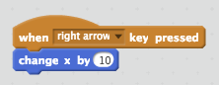
5. Do the same for the other arrows, so the cat can move in all directions

6. Now make it so the cat can’t go through walls

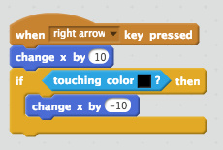

7. Do the same for the other directions

8. Double check that the cat is small enough to move through the maze, and doesn’t start out touching a color. Why is this important?

9. Test -- can you get your sprite through the maze?

WAY TO GO!!!
And if you get this far, there’s more on the other side!

10. Add a “goal sprite.” When your sprite reaches the goal, have it say (with a speech bubble) “Yay, I won!”

11. Add “prizes” for the sprite to collect in the maze. Give them points if they collect prizes.

12. Make the prizes appear in random locations, and only stay for a period of time.

13. Add a timer--if they run out of time they “lose”.

14. Add additional levels.

15. Add enemies that chase them (but also can’t go through walls)

